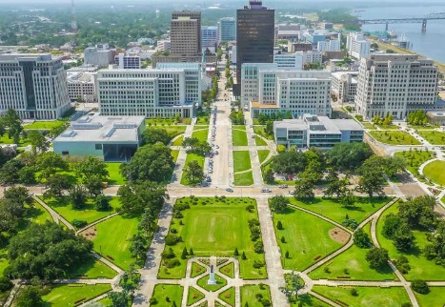

2019 Victim Offender Dialogue Summit & NAVAC Conference
The Hilton Capitol Center
May 20, 2019 – May 24, 2019

“Quality Victim Services Following Conviction:
Learn from the Past, Prepare for the Future”

The 13 Annual National Association of Victim Assistance in Corrections Conference will provide participants with information, skills, and insight to the best practices in the field of Post-Conviction Victim Services. For a full conference Agenda, including the Angola tour, please visit: www.navac.website

Keynote Speaker: To Be Announced

LODGING
Rooms have been reserved onsite at the Hilton Hotel, Downtown Baton Rouge. Please use the code (HAVAC) when making reservations. You are required to make your own reservations. Special Room Rate is the federal rate of $100 per night. YOU MUST RESERVE YOUR ROOM BY APRIL 28, 2019 TO RECEIVE THIS RATE. If you miss the deadline, we cannot guarantee room rate.
Phone number for the hotel is: 1-225-344-5866 or 1-800-955-6962. Visit the hotel website for more information: https://www.hilton.com/en/hi/groups/personalized/B/BTRCPHF-HAVAC-20190519/index.jhtml?WT.mc_id=POG

ABOUT BATON ROUGE

Baton Rouge is the state capital of Louisiana, and the 2019 NAVAC Conference location has been chosen with you in mind. The Old State Capitol is open for tours and is only a block away from our hotel.

The Baton Rouge Airport is about 15 minutes away from the Conference Hotel and the Hilton Downtown has a free guest shuttle service that travels to/from the airport. Guests should call the hotel following landing at 225.344.5866 to minimize delay.

Visit here for a guide to “things to do in Baton Rouge”: https://www.visitbatonrouge.com

Be sure to bring comfortable walking shoes and be prepared for warm sunny weather – sure hope you can join us in Baton Rouge in May!

NAVAC Membership: Membership questions, contact Anne-Marie Easley: aeasley@corrections.state.la.us

REGISTRATION FORM – PRINT and MAIL IN
2019 Victim Offender Dialogue Summit & NAVAC Conference

Name/Profession:
Agency/Organization:
Address: City/State/Zip:
Phone: Fax: _______ Email:
Dietary Needs:
Breakfast and Lunch will be provided each day.
Mid-morning and afternoon snacks will be available.

I will be attending the following:

VOD Summit ONLY $175
Check this box if you plan to attend the Angola Tour on Monday. Bus leaves hotel at 8:15 am and will return at 4:30 pm. YOU MUST HAVE ID with you to attend Angola Tour.
Monday – Angola Tour & VOD Experience. Welcome Reception at 5:00 pm.
Tuesday – VOD Summit at Hotel

NAVAC Conference ONLY $275
Wednesday- Friday @ Noon
Board Meeting – Friday afternoon

5-Day VOD Summit/NAVAC Conference $400

PAYMENT INFORMATION: Pay by check or credit/debit card
IMPORTANT: Please make checks payable to NAVAC
OR, for Credit Card, fill out ALL of the following:
Card Number: _________________________________ Exp. Date ____/____/____ Security Code: _________
Name on Card (Please Print): _______________________________________________________________
Cardholder Signature (REQUIRED): __________________________ Cardholder Zip Code (REQUIRED): _________

Submit this Registration form along with payment to:
NAVAC, c/o Saydyie DeRosia,
PO Box 4312, Salem, OR 97302
Or scan and email to: Saydyie.L.DeRosia@doc.state.or.us or Fax: 503-378-6248

Refunds will be given for registration cancellation if request is received by April 15, 2019

NAVAC Membership: Membership questions, contact Anne-Marie Easley: aeasley@corrections.state.la.us

